U:\Private\pbarnes\Branding\Branding junk\bihorizcolour.TIF

**RE: FAW SAFEGUARDING ROADSHOWS**

The Football Association of Wales warmly invites you to attend the FAW Safeguarding Roadshow on Tuesday 10th July 2018 at *Dragon Park; Newport International Sports Village, Newport, NP19 4RA*. The session will begin at 18:30, with arrivals from 18:00. Food will be available upon arrival and a question and answer session will follow the presentation.

The workshop will last approximately two and a half hours and will incorporate a presentation on the day to day duties of being a Club Safeguarding Officer, as well as information on the Club Accreditation Process. Topics covered include the DBS check process, FAW DBS risk assessment procedures for coaches and volunteers, referrals, day to day Safeguarding related queries and the Club Accreditation process. The FAW would like to request that no more than two attendees are present from each organisation at this workshop. As a priority we would ask that the Safeguarding Officer and Accreditation Officer attend, however, if they are unable to attend please feel free to send another representative.

Please confirm or decline your attendance by completing the RSVP section below. This can be returned to the FAW via email at [safeguarding@faw.co.uk](mailto:safeguarding@faw.co.uk), or via post to the address at the top of this invite.

***PLEASE RSVP BELOW***

*Will you be attending this event?* *Do you have any additional access requirements for the venue or presentation? If so, please provide details below:*

_________________________________________________________________________________

*Name of organisation you represent: ___________________ _________________________________________________________________________________*

*Full names and roles of attendees:* *Do you have any dietary restrictions? If so, please provide details below:*

1. ______________________________________________ _________________________________________________________________________________
2. ______________________________________________ _________________________________________________________________________________

*Please feel free to write down any Safeguarding or Accreditation related questions or issues you may wish to raise with the team so we can look in to this to provide an answer on the night for you:*

____________________________________________________________________________________________________________________________________________________________________________________________________________________________________________________________________________________________________________________________________________________________________________________________________________________________________________________________________________________________________________________________________________________________________________________________________________________________________________________________________________________________________________________________

11/12 Neptune Court 11/12 Cwrt Neifion

Vanguard Way Ffordd Blaen Gâd

Cardiff Caerdydd

CF24 5PJ CF24 5PJ

T 029 2043 5830

F 029 2049 6953

www.faw.org.uk

Yes No

Football Association of Wales Limited, Registered in London (England and Wales), Company Number 00213349.

FA WALES | CBD CYMRU is the trading name of Football Association of Wales Limited, Registered Office as above.

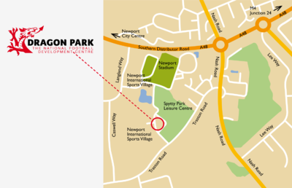 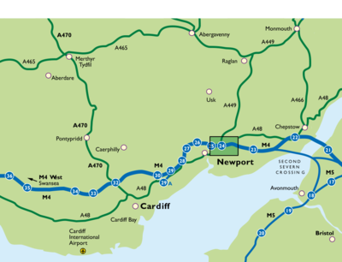

**Access By Road**

From M4 motorway, Junction 24 (the Coldra).   
At the roundabout take 4th exit (from Cardiff and West) or take 1st exit (from London and East) sign posted A48 Newport City Centre and Newport International Sports Village (NISV).

Continue along the distributor road (dual carriageway) for about 2 miles passing Tesco’s and Citroen garage on left hand side. (Follow brown tourist Sports Council signs for the NISV)

Turn left at Carcraft and take next left into Newport International Sports Village.

**Access By Bus**

Newport International Sport Village (NISV) has a number of transport buses (services 42 and 43) that travel past the northern perimeter of the site via the A48.

Walking time from bus stops on the A48 to NISV is approximately 10 minutes.

**Access By Rail**

Take the Great Western Service to Newport Gwent, which is on the main South Wales to London Paddington Line.